TCP/IP SUITE Theory

Q1. Open Wireshark, capture network traffic while you refresh the Flipkart homepage, and identify one packet each belonging to the Application, Transport, Internet, and Network Access layers by examining their headers.
Ans.
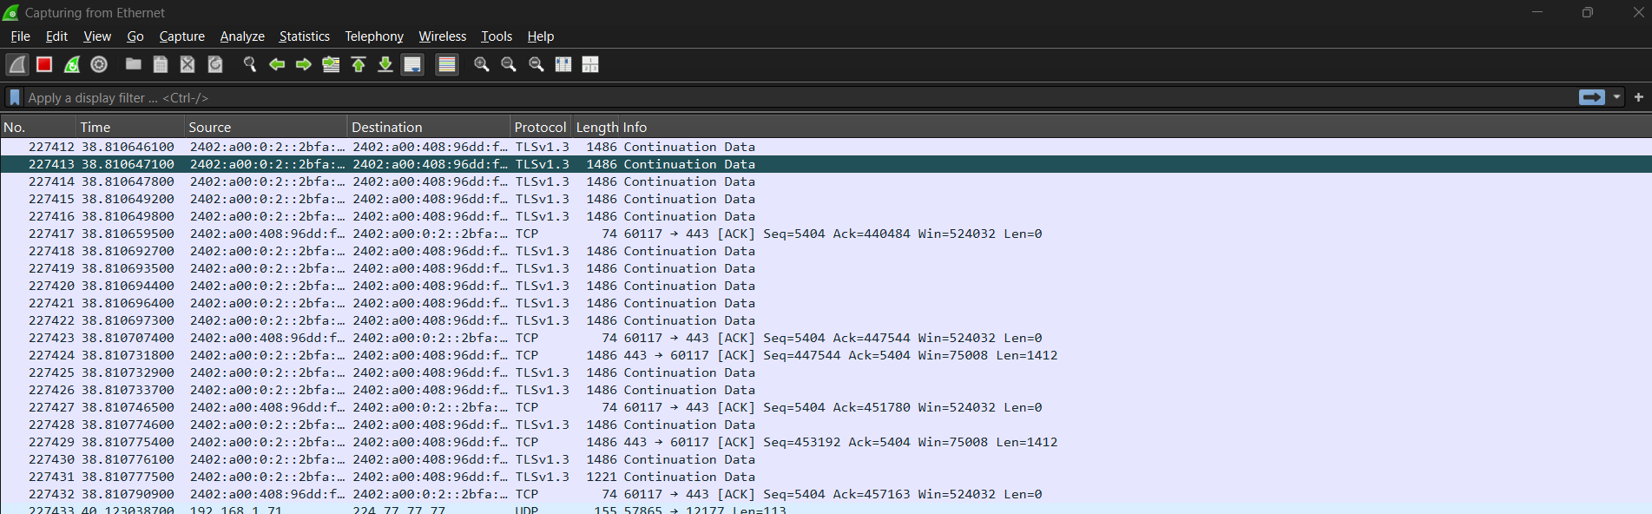
The Wireshark capture shows:
- Application: TLS 1.3 — encrypted HTTPS traffic.
- Transport: TCP — port 60117 → 443.
- Internet: IPv6 — source and destination IPv6 addresses are shown.
- Network Access: Ethernet II — contains source/destination MAC addresses and IPv6 Ether Type.
Conclusion: The Flipkart traffic successfully demonstrates all four layers.
Q2. Create a table comparing the OSI and TCP/IP models, listing all layers side-by-side, and for each layer, give a real-world example from any app you use (e.g., WhatsApp message, Zomato order).
Ans.
OSI Model | TCP/IP Model Layer | Real-World Example
7. Applications | Application | WhatsApp Message
6. Presentations | Application | Message Encryption/Formatting
5. Session | Application | Maintaining a WhatsApp Connection
4. Transport | Transport | TCP/UDP Delivering
3. Network | Internet | IP Address Routing a Zomato Request
2. Data Link | Network Access | Wi-Fi/Ethernet frames
1. Physical | Network Access | Wi-Fi radio signals/cables

Q3. Given a screenshot of a TCP segment header (provided by your trainer), label the fields that belong to the Transport layer and explain what each field does in 1-2 lines. Hint: Look for fields like Source Port, Destination Port, Sequence Number, etc.

Ans. TCP Segment Header – Transport Layer Fields
Field | What it Does
Source Port | Identifies the application sending the data
Destination Port | Identifies the application receiving the data.
Sequence Number | Keeps track of the position of data so it can be reordered correctly.
Acknowledgment Number | Tells the sender which data has been successfully received.
Header Length (Data Offset) | Shows the size of the TCP header.
Flags | Controls TCP functions such as connection setup, termination, and acknowledgment (SYN, ACK, FIN, etc.).
Window Size | Indicates how much data the receiver can accept before needing more acknowledgments.
Checksum | Detects errors or corruption in the TCP segment.
Urgent Pointer | Indicates the location of urgent data when the URG flag is set.
Options | Provides additional TCP features, such as maximum segment size and timestamps.

Q4. Draw a diagram showing how a message sent from your device to Instagram's server passes through each TCP/IP layer, and annotate what happens at each step using simple app-related terms (e.g., 'message split into packets', 'IP address added', etc.).
Ans.
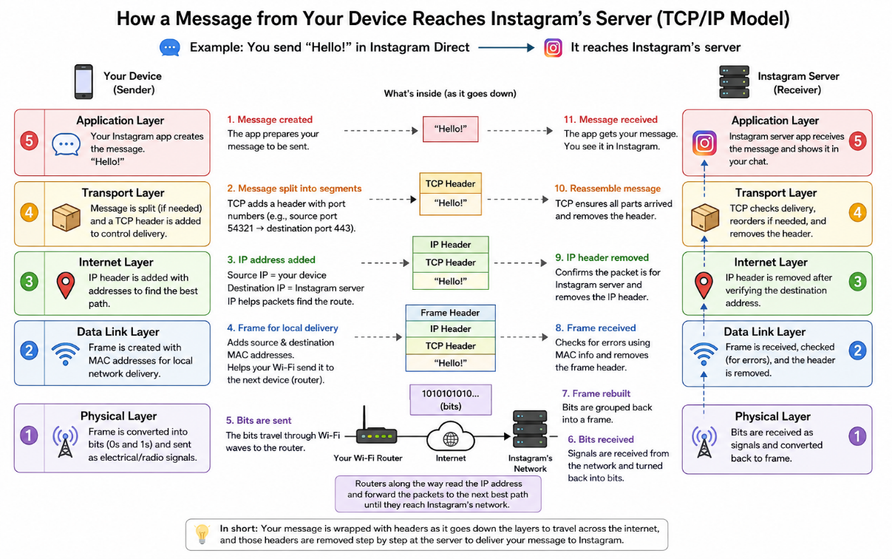

Q5. Pick any one packet you captured in Wireshark and write which TCP/IP layer it belongs to, how you identified it, and what real-world action in an app (like sending a WhatsApp message or booking a ticket on BookMyShow) it represents.
Ans. Wireshark Packet Analysis
- TCP/IP Layer: Transport Layer
- Protocol: TCP
- How I identified it: The packet contains TCP fields such as Source Port, Destination Port, Sequence Number, and Acknowledgment Number.
- Real-world action: It represents data being sent between my device and an app server, such as sending a WhatsApp message. TCP helps ensure the data reaches the server reliably and in the correct order.

